**You must log your scanner usage on the iLab Kiosk before the start of the scan**

**Method 1: Using your cell phone**

1. Scan this QR code using your phone:

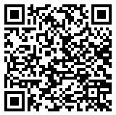

2. Sign in with your JHED credential and password;

3. Click the Start button for your scan.

**Method 2: Using the workstation**

1. Log in the workstation using your JHED credential and password;

2. Click to open the “Kiosk” shortcut on the desktop and log in;

3. Click the Start button for your scan.

**After the scan is finished**

Click the Finish button on the Kiosk to log off for your scan.

If you are using the workstation, remember to log off the workstation.